Multimodal Feature Fusion Report
The combine_features.py script implements the final integration layer for multimodal Parkinson's disease detection, merging keystroke features from the Tappy and NeuroQWERTY (MIT-CS1/CS2) datasets into unified training matrices. This addresses the critical challenge of heterogeneous feature spaces across different data sources, while Tappy provides 25 features derived from binary key classifications (K = alphanumeric keys, S = spacebar), NeuroQWERTY offers 30+ features using a ternary classification system (K/S/P, where P = punctuation and other non-alphanumeric tokens) and includes UPDRS (Unified Parkinson's Disease Rating Scale) clinical severity scores. The UPDRS is a standardized clinical metric (ranging from 0 to 108) that quantifies Parkinson's symptom severity, enabling regression analysis beyond simple binary classification.
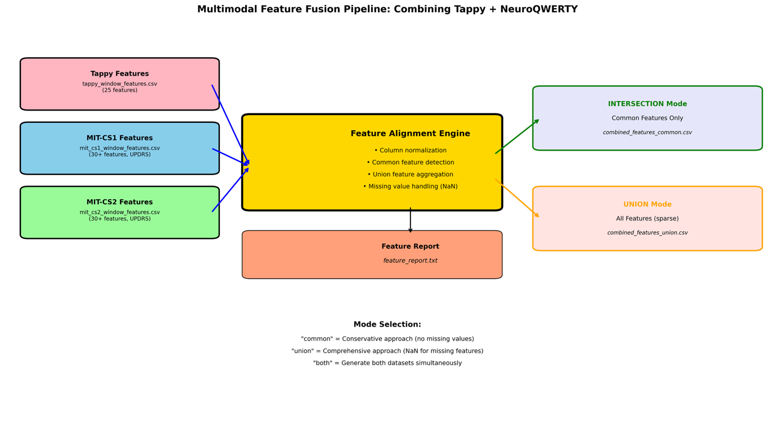
Figure 1: Multimodal Feature Fusion Pipeline
Data Processing and Alignment The pipeline ingests three preprocessed feature files and executes a column normalization routine to handle formatting inconsistencies. It automatically identifies identifier columns (dataset, subject_id, session_id, window_id) and label columns (label_pd, updrs), then performs set operations on the remaining numeric features. The system computes both the intersection (features present in all three datasets) and the union (features present in any dataset) of the feature spaces.
Feature Set Operations The intersection mode (approximately 18 shared features including hold_mean, dd_std, pause rates, and basic digraphs) produces a dense matrix suitable for standard machine learning algorithms requiring complete cases. The union mode (30+ features) creates a sparse matrix where NeuroQWERTY-specific features, such as punctuation-aware digraphs (KK, KP, PP, etc., where the P classification captures punctuation keys unlike Tappy's binary system)—and UPDRS scores are populated for MIT-CS samples but marked as NaN for Tappy samples. This design enables imputation experiments or dataset-specific analyses while maintaining a unified schema. The script intelligently handles missing columns by injecting NaN values rather than failing, ensuring robustness against schema variations.
Pipeline Outputs The system generates three artifacts: (1) combined_features_common.csv containing the intersection set with no missing values, optimal for conservative multimodal classification; (2) combined_features_union.csv containing all features with strategic NaN placement for comprehensive analysis; and (3) feature_report.txt documenting the overlap statistics, dataset-specific features, and diagnostic metadata. Users select their preferred mode via the --mode parameter (common, union, or both), with "common" recommended for production classification pipelines and "union" reserved for exploratory feature importance analysis.
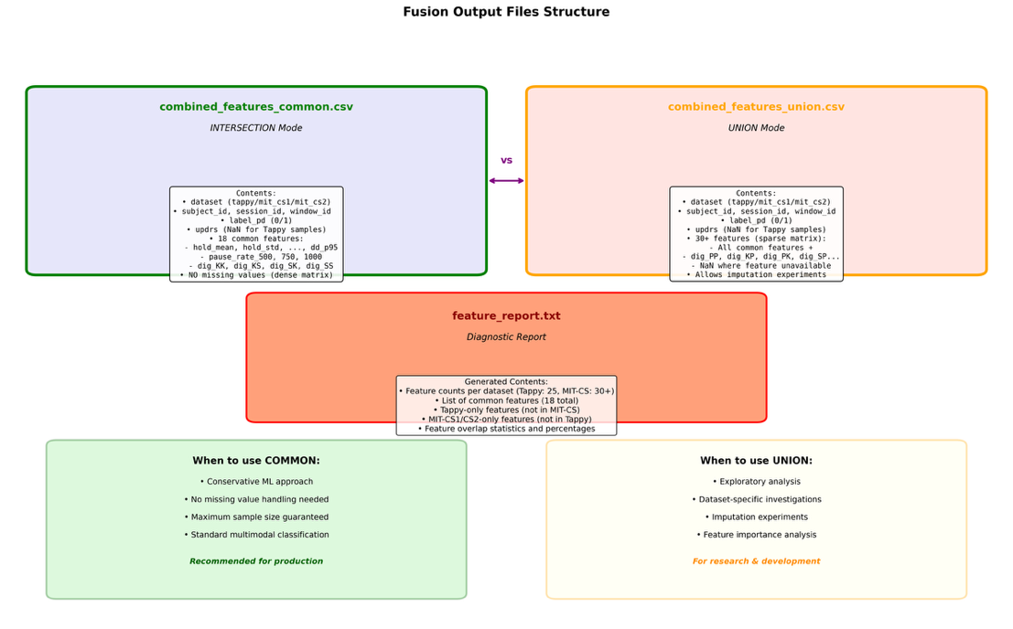
Figure 2: Output Structure

Clinical Integration Notably, the pipeline preserves UPDRS scores from NeuroQWERTY datasets—representing clinical Parkinson's severity ratings where higher scores indicate worse motor symptoms—while allowing Tappy samples to have NaN values in this field. This enables both binary classification (PD vs. Healthy) and regression analysis (severity prediction) on the same fused dataset, using the subset of samples with UPDRS annotations for the latter task. The resulting unified datasets serve as the foundation for cross-dataset validation and multimodal ensemble learning strategies.

